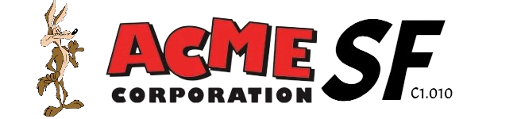

Chartering report

Repository: https://github.com/C1-010/Acme-SF-D01

Group: C1.010

García Rivero, Andrés Francisco -[andgarriv@alum.us.es](mailto:andgarriv@alum.us.es)

López Cubiles, Antonio José - [antlopcub@alum.us.es](mailto:antlopcub@alum.us.es)

Nieto Vicioso, Javier - [javnievic@alum.us.es](mailto:javnievic@alum.us.es)

Díaz Ordoñez, Pablo -  [pabdiaord@alum.us.es](mailto:%20pabdiaord@alum.us.es)

Sevillano Barea, Alejandro - [alesevbar@alum.us.es](mailto:alesevbar@alum.us.es)

February 15th, 2024

Content Table

1. Executive Summary 2

2. Revision Table 2

3. Introduction 2

4. Contents 3

5. Conclusions 5

6. Bibliography 6

# 1. Executive Summary

This report will outline the recruitment process, team commitments, performance evaluation mechanisms, and management procedures for a project milestone. It begins with an overview of how the team was assembled and the criteria for member selection, emphasizing collaboration, communication, and commitment. Contact information for each team member is provided. Additionally, the commitment statement highlights the team's dedication to working together and understanding project objectives. Performance indicators, reward systems, admonishment procedures, and termination conditions are detailed to ensure efficient project management. The report concludes with the date and signatures of all team members, demonstrating their agreement and commitment to the project's success.

# 2. Revision Table

|  |  |  |
| --- | --- | --- |
| Revision number | Date | Description |
| 1 | 14/02/2024 | Created this report and almost fulfill it |
| 2 | 15/02/2024 | Review and addition of information for each member |

# 3. Introduction

In this section, we provide a concise overview of the contents of this document. We begin by outlining the key aspects covered, including the recruitment process, team commitments, performance evaluation mechanisms, management procedures for our project milestone, and the performance indicators.

Our report starts with an examination of how our team was formed and the criteria used in selecting its members, emphasizing qualities such as collaboration, communication, and commitment. Following this, we offer contact information for each team member to facilitate seamless communication throughout the project.

Additionally, we present our commitment statement, affirming our dedication to collective success and our understanding of project objectives. **We also expose** our performance indicators, which will **measure** our efficiency and productivity, as well as our interactions with stakeholders through customer or lecturer ratings.

Furthermore, we outline our reward system for members who demonstrate good performance, our admonishment procedures for those with poor performance, and termination conditions for extreme cases. Finally, the report concludes with the date and signatures of all team members, symbolizing our collective agreement and commitment to the project's success.

Through this structured approach, we aim to provide a clear framework for effective project management and ensure clarity and transparency in our collaborative efforts.

# 4. Contents

**Summary of Recruitment**:

The manager for this first milestone was self-selected and took charge of organizing the work environment, including the repository, to facilitate collaboration. Through meetings, the manager recruited us to achieve the objectives of this initial deliverable.

**Contact Information**:

García Rivero, Andrés

Email: andgarriv@alum.us.es

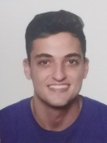

Nieto Vicioso, Javier

Email: [javnievic@alum.us.es](mailto:javnievic@alum.us.es)

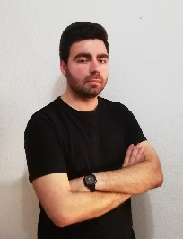

López Cubiles, Antonio José

Email: antlopcub@alum.us.es

Díaz Ordoñez, Pablo

Email: pabdiaord@alum.us.es



Sevillano Barea, Alejandro

Email: alesevbar@alum.us.es

**Commitment Statement**:

All team members are committed to working together on this project. We have established good communication, which is key in a group project. We have all reviewed and understood the syllabus and evaluation procedures, and we are committed to giving our best performance in the project.

**Performance Indicators**:

For our project, one key performance indicator will be the ratio of completed tasks to the total tasks assigned. This indicator will provide insight into the efficiency and productivity of our workgroup members. Additionally, we will consider customer or lecturer ratings as another performance indicator, reflecting the quality of our deliverables and our interactions with stakeholders.

In terms of what constitutes "performing well" and "performing poorly" based on these indicators, we will define the following:

Performing Well:

Completing at least 90% of assigned tasks within the specified timeframe.

Receiving consistently positive ratings from customers or lecturers (during follow-up sessions), indicating satisfaction with the quality of work and professionalism.

Performing Bad:

Completing less than 60% of assigned tasks within the specified timeframe.

Receiving consistently negative ratings from customers or lecturers, indicating dissatisfaction with the quality of work or communication.

These definitions will serve as clear benchmarks for evaluating the performance of our workgroup members and guiding improvement efforts as needed.

**Reward System**:

Team members who demonstrate good performance will be rewarded with public recognition and leadership opportunities in future milestones.

**Admonishment Procedure**:

Team members with poor performance will receive formal warnings and will be offered additional support and training opportunities to improve their performance.

**Termination Conditions**:

A team member may be fired if their performance continues to be unsatisfactory after receiving warnings and additional support. They will be given the option to continue working independently or to withdraw from the project.

**Date and Signatures**:

This report is dated February 14, 2024. All team members are willing to sign the report to indicate their agreement and commitment to its content.

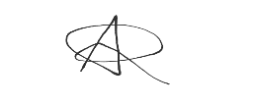

___________________________ García Rivero, Andrés Francisco

___________________________ Nieto Vicioso, Javier

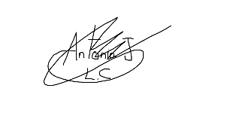

___________________________ López Cubiles, Antonio José

___________________________ Díaz Ordoñez, Pablo

___________________________ Sevillano Barea, Alejandro

# 5. Conclusions

This report provides a solid foundation for our project's management and team collaboration. We've outlined recruitment, commitments, performance indicators, and management procedures clearly. Our commitment to communication and dedication is evident. The defined performance indicators, reward system, and admonishment procedures ensure accountability and support improvement. The signatures affirm our collective commitment. With this framework, we're poised for success, fostering excellence and collaboration.

# 6. Bibliography

Intentionally blank.